Assignment #6 — JavaScript Basics (DOM Manipulation & Events)
Student: Adilbek Arman
Group: SE-2432

Part 1 — Introduction to JavaScript
Task 0 — First Script
Goal:
Create a simple HTML page and include a JavaScript file that prints a message and your name in the console.
Description:
The script uses console.log() to print my name and group, and displays an alert message saying
"Hello, JavaScript World!"
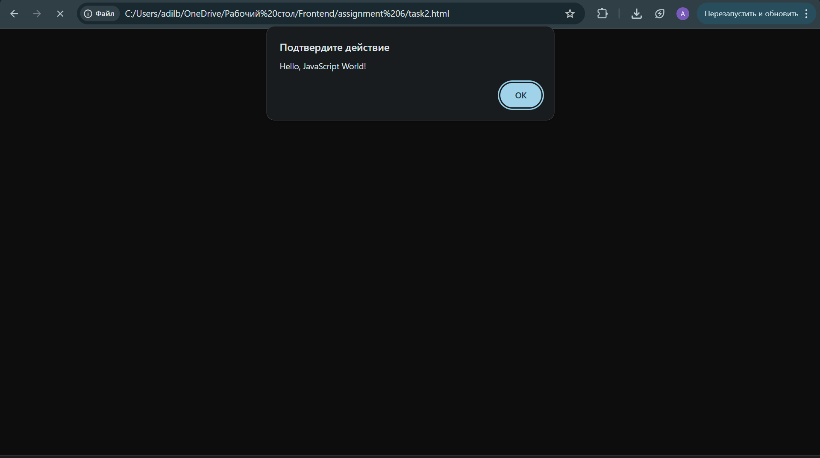
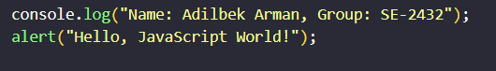

Task 1 — Variables & Operators
Goal:
Declare variables of different data types and perform arithmetic and string operations.
Description:
This task demonstrates how to create variables (string, number, boolean), perform addition, and concatenate strings.
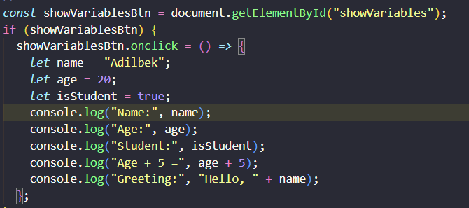
Part 2 — DOM Manipulation
Task 2 — Changing Content
Goal:
Change HTML content using JavaScript.
Description:
When the button is clicked, the paragraph text changes to a new message using
innerText.
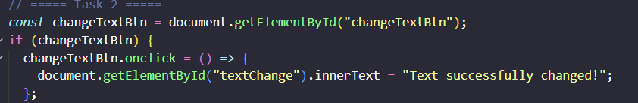
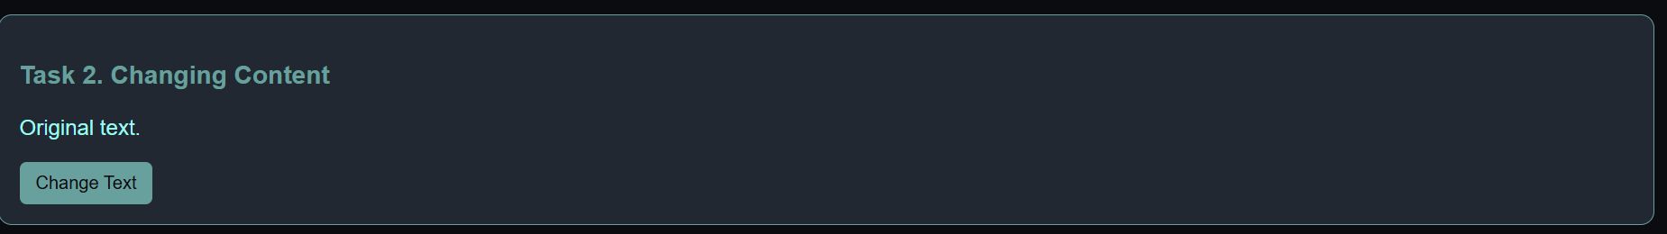
Task 3 — Changing Styles
Goal:
Change the style of elements dynamically.
Description:
Two buttons are used — one changes the background color, and another changes the font size of a <div> element.
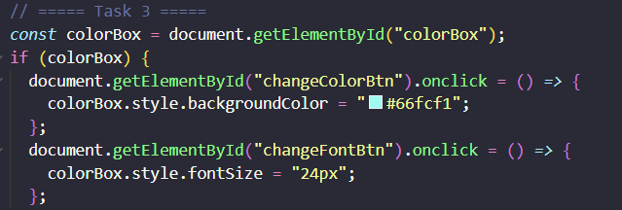
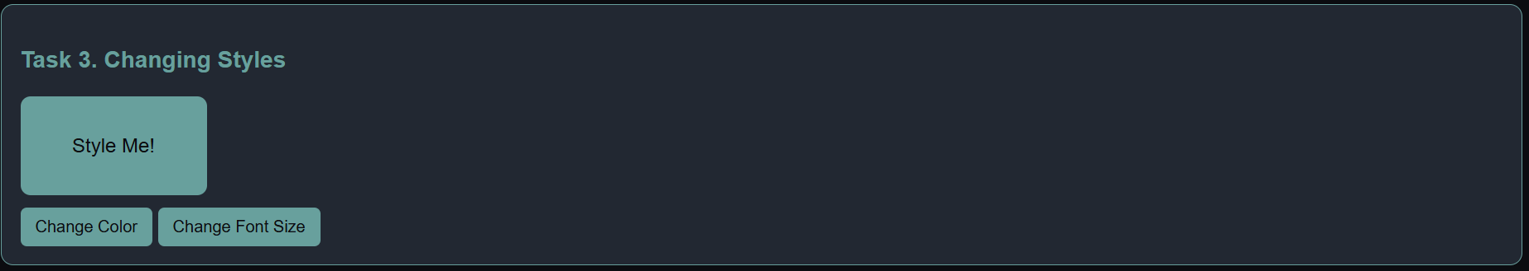
Task 4 — Creating & Removing Elements
Goal:
Add and remove list items using JavaScript.
Description:
The Add Item button creates a new <li> and appends it to the list, while the Remove Item button removes the last one.
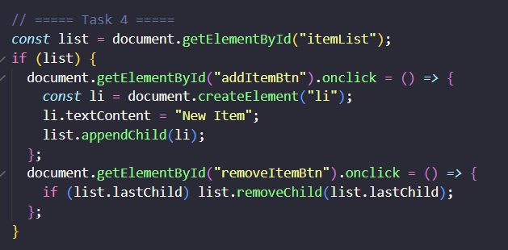
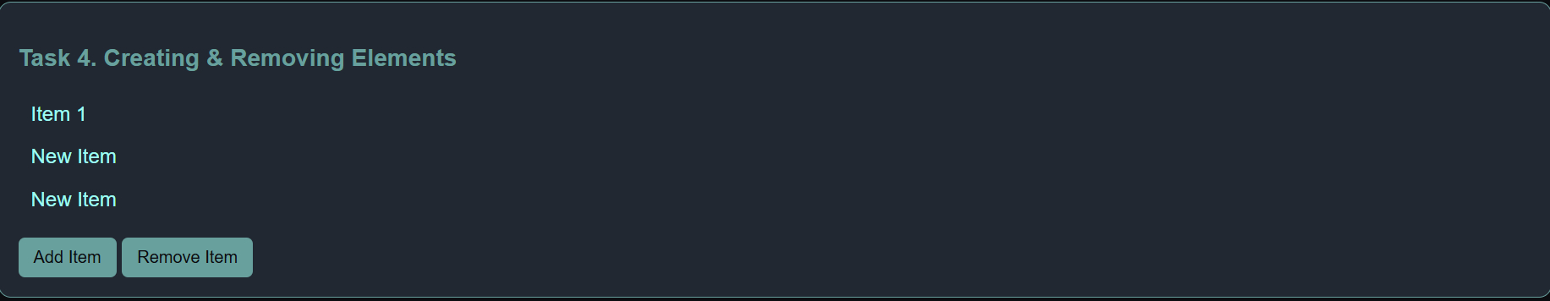
Part 3 — Events
Task 5 — Mouse Events
Goal:
React to mouse actions on an element.
Description:
When the user hovers over a box, its color changes.
When the mouse leaves, the original color is restored.
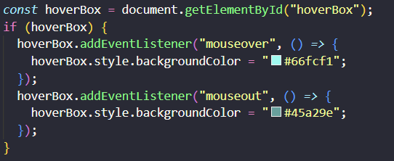
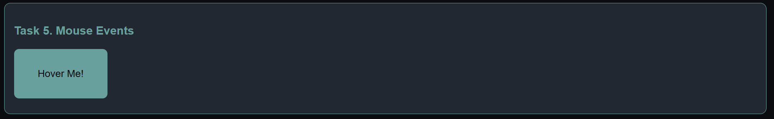
Task 6 — Keyboard Events
Goal:
Display input text in real time.
Description:
When typing in the input field, the current text is displayed immediately using the keyup event.
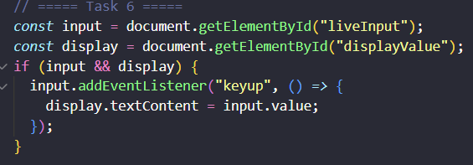
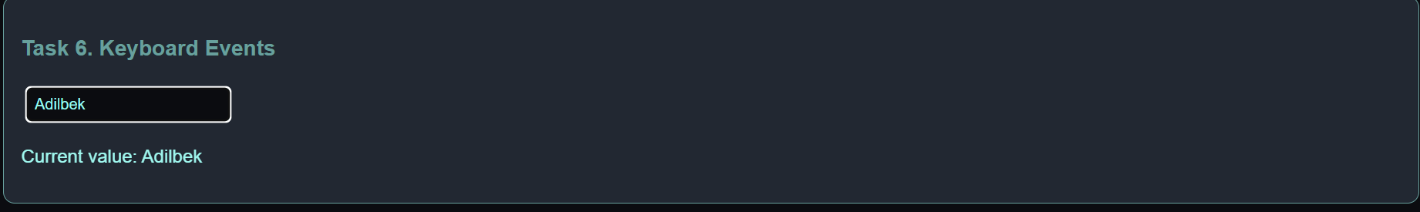Task 7 — Calculator
Goal:
Build a simple calculator using JavaScript.
Description:
Performs addition, subtraction, multiplication, and division using function calculate()
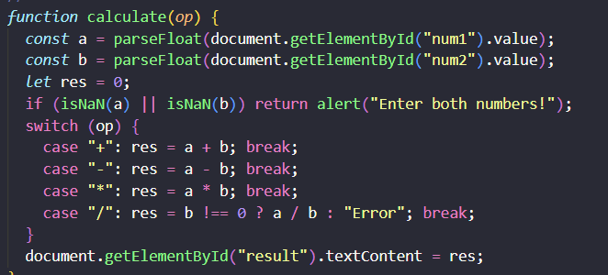
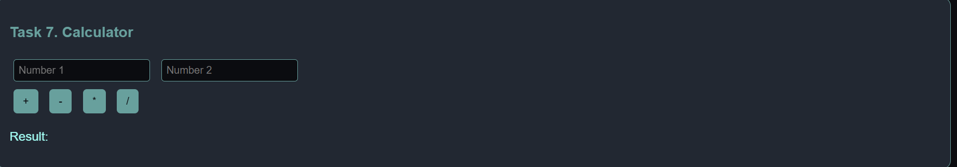
Part 4 — Mini Project: Interactive To-Do List

Task 8 — Build a To-Do App
Goal:
Create an interactive To-Do List that allows adding, marking, and deleting tasks.
Description:
Users can type a task, add it to the list, mark it as completed (strike-through), and delete it.
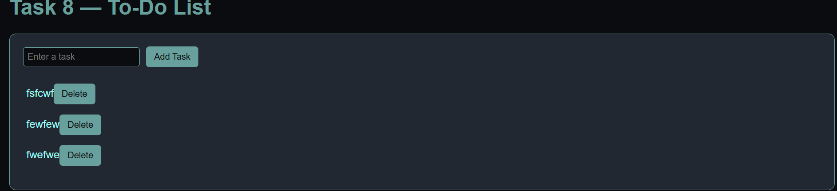
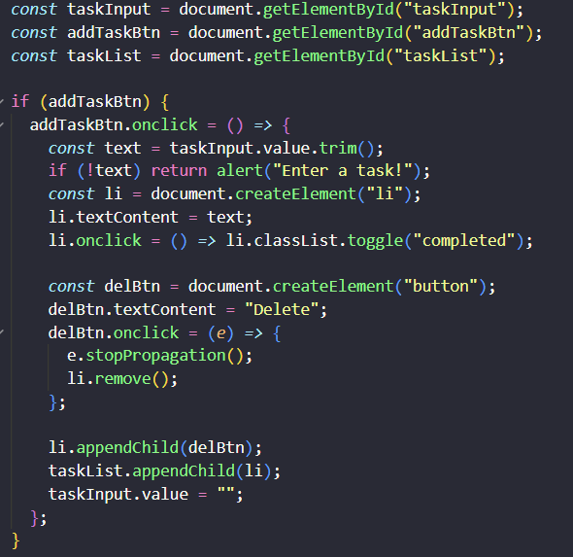
Summary of Work Process
In this assignment, I practiced the basics of JavaScript, including:
- Declaring variables and using operators,
- Manipulating the DOM (changing text, styles, and creating/removing elements),
- Handling mouse and keyboard events,
- Building an interactive mini project (To-Do List).
I also used a black & turquoise color theme to keep the design consistent and readable.
The project demonstrates my understanding of DOM manipulation, event handling, and basic web interactivity.

